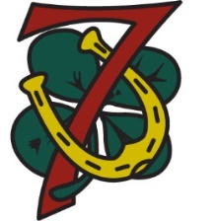
TROOP 7
WELCOME TO THE TROOP – SHOPPING LIST AND REGISTRATION
Hello and welcome to Troop 7. The info on these sheets will give you a good start with the troop.
Our website is: http://www.troop7bsa.com/. There you’ll find useful links and our calendar. Take a look at the ‘NEW TO SCOUTING?’ tab.
Below is a shopping list for the Scout Shop in Massapequa. It's the best place to get everything your new scout will need. 544 Broadway, Massapequa, NY 11758, (516) 797-7600, Open: 8:30AM–7PM
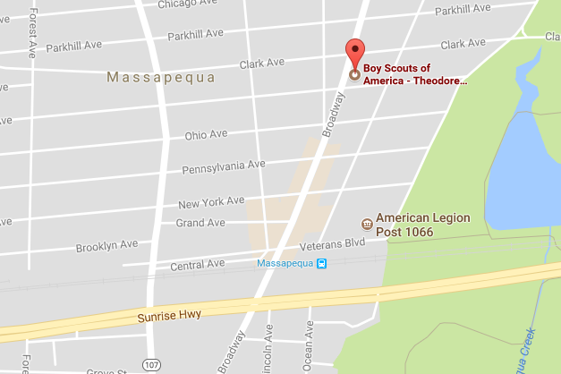
Items to get:
Boy Scout Handbook (w/ opt. cover)
Short-sleeved scout shirt with TR Council & 'World Crest' patches
Green Boy Scout epaulets (shoulder loops)
#7 patch
Scout pants
Scout socks
Belt
Neckerchief slide - Andy will provide a neckerchief for you.

BSA Annual Medical Form: There is a link on our website’s ‘NEW TO SCOUTING?’ tab and at: http://www.trcbsa.org/Resources/AnnualHealthMedicalRecord

Boy Scout Youth Protection Training: Information can be found on our website’s ‘NEW TO SCOUTING?’ tab and at: http://www.trcbsa.org/Training/Youth-Protection-Training

Register with BSA:
1. Go to BeAScout.org. Select 'Get Started'. Select 'Boy Scouts', put in your zip code, press the right facing arrow next to the zip code, then when the map refreshes, press 'Show Unit' below troop 7.
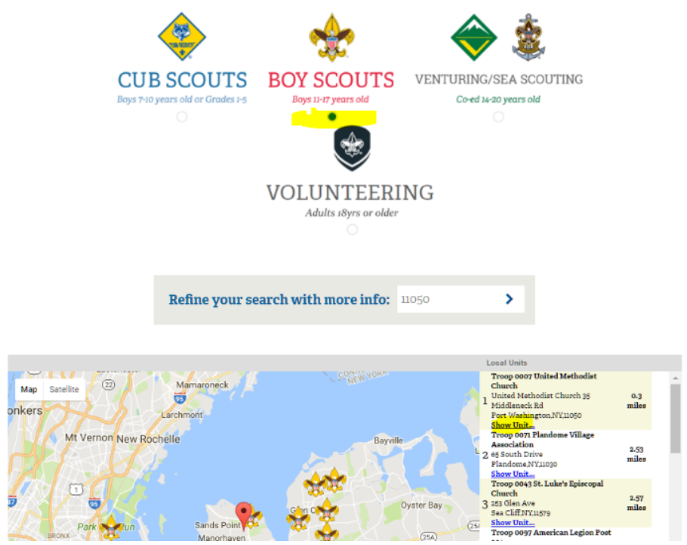
2. On the popup select 'Apply Now'
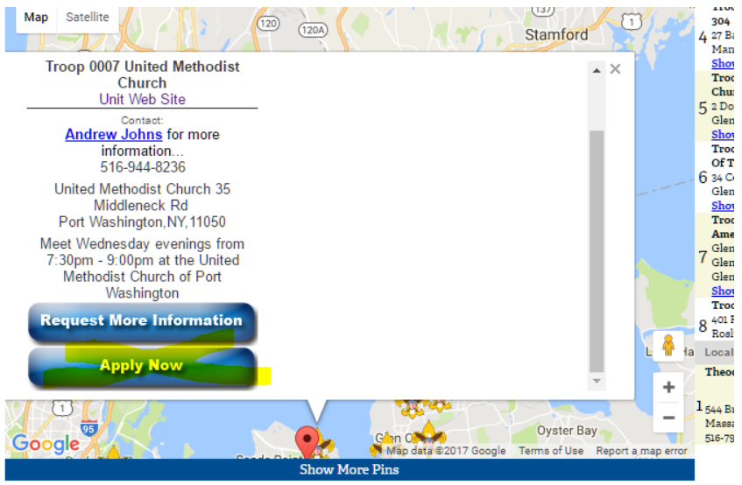
3. You'll be redirected to my.scouting.org (the main scouting website) then select 'Continue' under 'New to Scouting'. Then select 'Register a Youth'. There are three main steps to fill out:
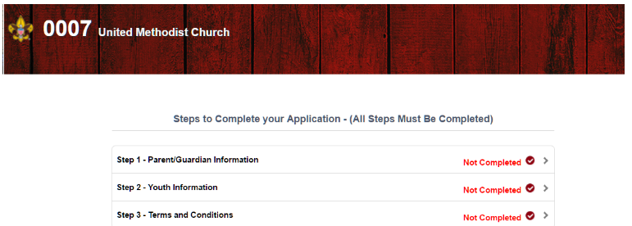
4. Once this process is done, let us know. Andy has to then approve you online and then we can start setting you up on Scoutbook.

