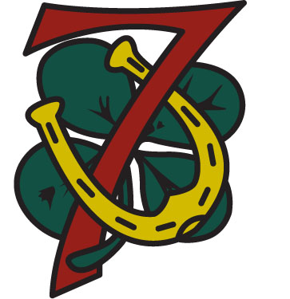
Troop 7 Onteora Summer Camp
Troop Equipment List

General Troop Equipment for site
Propane lanterns (3)
Propane – 1 pound canisters (5)
Extra mantles (6 bags)
20 pound propane tank (in shed)
Propane distribution tree
Hoses for propane distribution tree (1 or 2)
Axes (2)
Saws (2)
First aid kit
Cleaning buckets (3)
Sterilization tablets
Bag of rope
Ball of twine
Lock (for small shed)
Duct tape
Masking tape
Tools – pliers, claw hammer, galvanized nails, etc.
Tent stakes (8)
Latex gloves (box)
Work gloves (1 or more pairs)
Fireplace (insulated) gloves (1 pair)
Garbage bags (10)
Flags (American and Troop, on poles)
Patrol flags (made by patrols)
American flag for flagpole in site
Pencil box with Sharpies, pens, pencils
Sports equipment (football, Frisbee, etc.)
Extra car port, or large tarp and poles
5-gallon water jug

Cooking Supplies
Propane stove, 2 burner
Dutch oven
BSA hot pot tongs
Pot holder
Aluminum foil
Coffee pot / Tea pot
Cook pot set
Cooking utensils (set)
Plates / Coffee mugs
Dish soap and sponge
Plastic utensils
Measuring cups
Matches, lighters

For bulletin board
Sheet protectors
Push pins
Wall clock, Extra AA battery
Onteora program schedules/maps

Food for Camp Site
Coffee, Tea
Sugar, Creamer

For Long House, Scoutmaster Center
Lock (for charging station locker)
Power strip (for charging station locker)
Hot sauce

For latrine
Hand soap (2 dispensers, 64 oz. refill)
Paper towels (12 “big” rolls, select a size)
Night glow sticks
Splitter for faucet; male hose end; hose nozzle
Paper towel dispenser

Poly Envelope (w/side opening) for each Scout, containing:
- Composition notebook
- Name Labels (1 on envelope, 1 on notebook)
- Pen, Pencil
- Blue cards for pre-selected merit badges (if not electronic)
- Scout merit badge schedules, Onteora map

Other
T-Shirts
Special program theme items (hats, etc.)
Skit book

Scoutmaster’s Materials
Advancement Records
Alarm Clock
Camp Leaders Manual / Scoutmaster’s Handbook
Coat Hangers
Blank blue cards for changes/additions at camp (if not electronic)
Merit Badge Book Library
Extra copies of individual merit badge schedules
Poster Board
Troop Rosters (3 extra)
Extra copies of medicals (hard copy and/or on flash drive)
Stapler/staple remover/tape/scissors/hole punch
Pad
Board of Review question sheets

Dan Beard program supplies
Boy Scout Handbook, Rank requirements checklist
File for ax sharpening
Pocketknife
Whet stone for knife sharpening
Map of Onteora
2-3 compasses
Supplies for whipping and fusing ropes
Ropes for knot tying
Ropes for lashing
Triangular bandages
American flag
Onteora Orienteering Course

