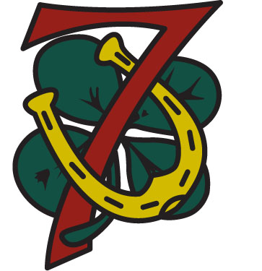
Troop 7 Onteora Summer Camp
Personal Gear and Packing List

Substantially all items should be packed in a foot locker and marked with the Scout’s name and Troop 7.
Alternatives include a duffel bag or backpack, but these are not recommended.

What to Wear and Carry for Arrival at Camp
- Wear Field (Class A) uniform – Scout shirt, Scout shorts, Scout socks, hiking boots, belt. No neckerchief – leave this home.
- Wear bathing suit underneath uniform (if haven’t already passed camp swim test for this year). If you use swimming goggles, put them in your day pack.
- Carry your day pack with the following items: rain gear, towel (for after swim test), lunch, drinking water, change of underwear (optional).
- Medications, in their original container, with instructions for administration clearly marked. These will kept and administered by the health care officer at camp.

Pack in the foot locker the following items

Clothing
Troop/Scout-themed T-Shirt(s) – “Class B” uniform (may be provided by Troop)
Extra T-Shirts (2-3)
Extra Shorts (1-2 pairs)
Long Scout pants or other long pants
Underwear (6 days)
Socks (6 days)
Fleece jacket or sweatshirt
Baseball-style cap (unless provided)
Extra Swim Suit and Towel
Pajamas
Casual Shoes or Sneakers
Shower shoes or sandals

Sleeping gear
Sleeping Bag
Pillow
Air Mattress/Sleeping Pad (optional)
Extra blanket/Sheet (optional)
Alarm Clock

Personal Hygiene
Toothbrush/Toothpaste
Shampoo, Soap, Deodorant, Comb
Other Items
Spending Money ($30-$50 suggested)
Extra may be needed for certain activities/events
Notebook and Pencils/Pens (Troop will supply)
Pre-camp work (prerequisites) for merit badges
Scout Handbook
Insect Repellent, Suntan Lotion (non-aerosol)
Flashlight with Extra Batteries
Canteen / Nalgene
Personal First Aid Kit
Compass
Hangers (for Class A uniform and other)
Light rope or twine (for clothesline inside tent)
Laundry Bag
Order of the Arrow (OA) Supplies (for OA members)

Optional Items
Camping chair (recommended)
Recreational items - Football, Frisbee, etc.
Devotional Text
Fishing gear
Drinking mug (plastic)
Plate, Bowl, Knife, Fork, Spoon
Merit badge books (can be purchased at camp)
Carabiners (for hanging items from clothesline)

THE FOLLOWING ITEMS ARE PROHIBITED AT CAMP:
- Personal Electronic Devices (Radio/Tape/CD/MD/Etc., Personal CB or FRS Radios, Cell Phones, Etc.)
- Personal Matches, Lighters, Fireworks or Similar Items, including but not limited to Firecrackers, Smoke Bombs, Bottle Rockets, etc.
- Aerosol Cans Of Any Kind
- Hunting or Sheath Knives of Any Size, and Personal Axes
- Firearms, Ammunition, and/or Personal Bows
- Alcohol, Illicit Drugs, Tobacco Products of Any Kind

